

Program No: | 09
Roll No : | 1525
Title of Program : | Implementation of analytical queries  Roll-up,CUBE
Objective : | Understand basic OLAP operations

Source code:

CREATE TABLE employee (
emp_no NUMBER(10),
dep_no NUMBER(10),
emp_name VARCHAR(25),
salary NUMBER(10),
comm NUMBER(10),
job VARCHAR(25)
);

insert into employee VALUES (101,10,'sanket',22000,1000,'assistent');
insert into employee VALUES (102,10,'josh',22000,1000,'assistent');
insert into employee VALUES (103,20,'hendry',22000,1000,'CLERK');
insert into employee VALUES (104,70,'sanket cha papa',22000,1000,'manager');
insert into employee VALUES (105,10,'abhay',22000,1000,'assistent');
insert into employee VALUES (106,50,'james',22000,1000,'CLERK');
insert into employee VALUES (107,10,'bond',22000,1000,'CLERK');
insert into employee VALUES (108,10,'hardik',22000,1000,'assistent');
insert into employee VALUES (109,70,'rohit',22000,1000,'manager');
insert into employee VALUES (110,90,'rishab',22000,1000,'CLERK');

select dep_no,job,count(*),sum(salary) from employee group by
rollup (dep_no,job);

OUTPUT:

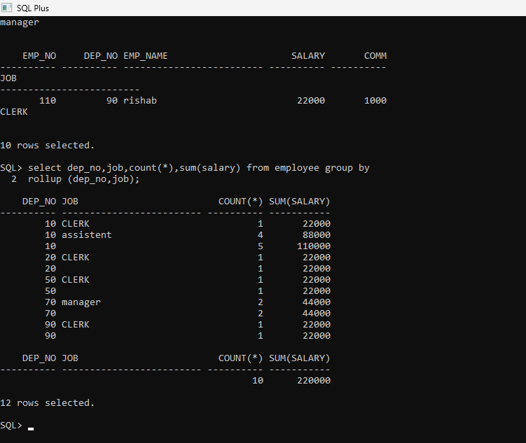

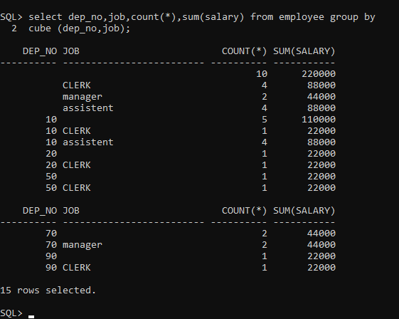

rownum:

select rownum,emp_name,salary from employee2;

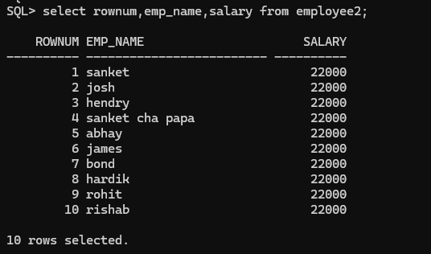

select rownum,emp_name,salary from employee2 order by salary;5 |

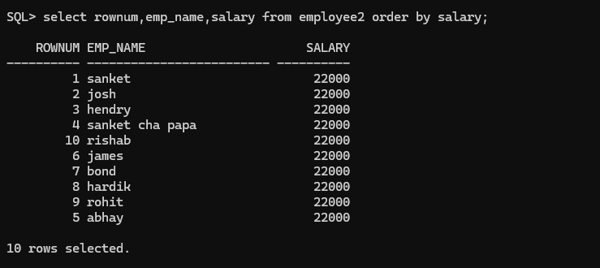
select rownum,emp_name,salary from employee2 order by salary desc;
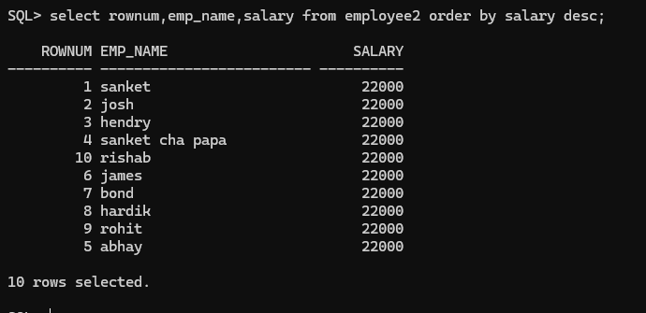
select emp_no,dep_no,salary,comm, rank() over(partition by dep_no order by salary)as Rank from employee;

